ASSIGNMENT 2

M.Ganeshkarthick(192321138)

1. Write a program to enter the marks of a student in four subjects. Then calculate the total and aggregate, display the grade obtained by the student. If the student scores an aggregate greater than 75%, then the grade is Distinction. If aggregate is 60>= and <75, then the grade is First Division. If aggregate is 50 >= and <60, then the grade is Second Division. If aggregate is 40>= and <50, then the grade is Third Division. Else the grade is Fail.

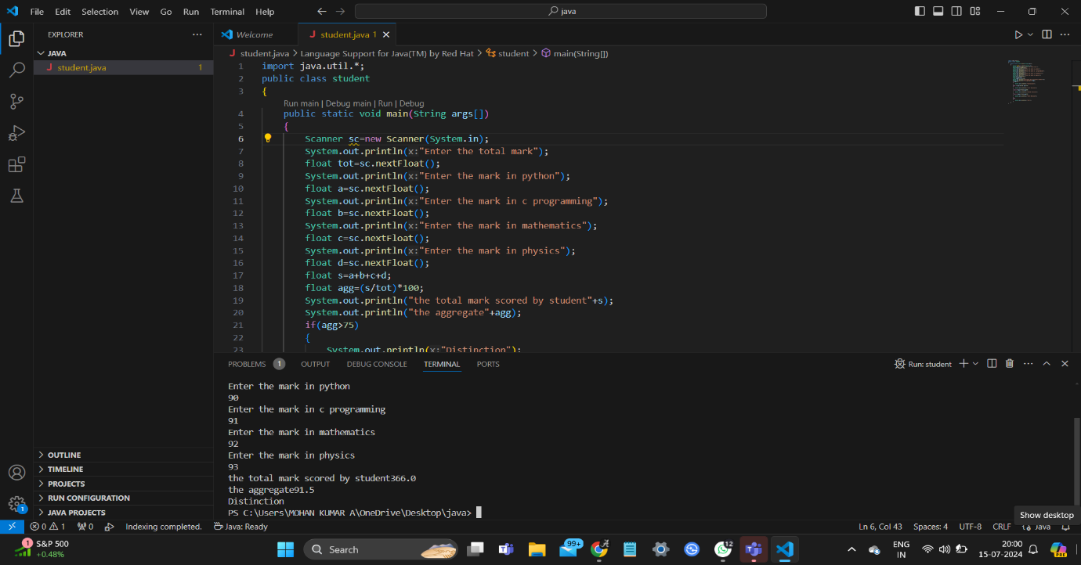

2) Write a program to find the number of special characters in the given statement

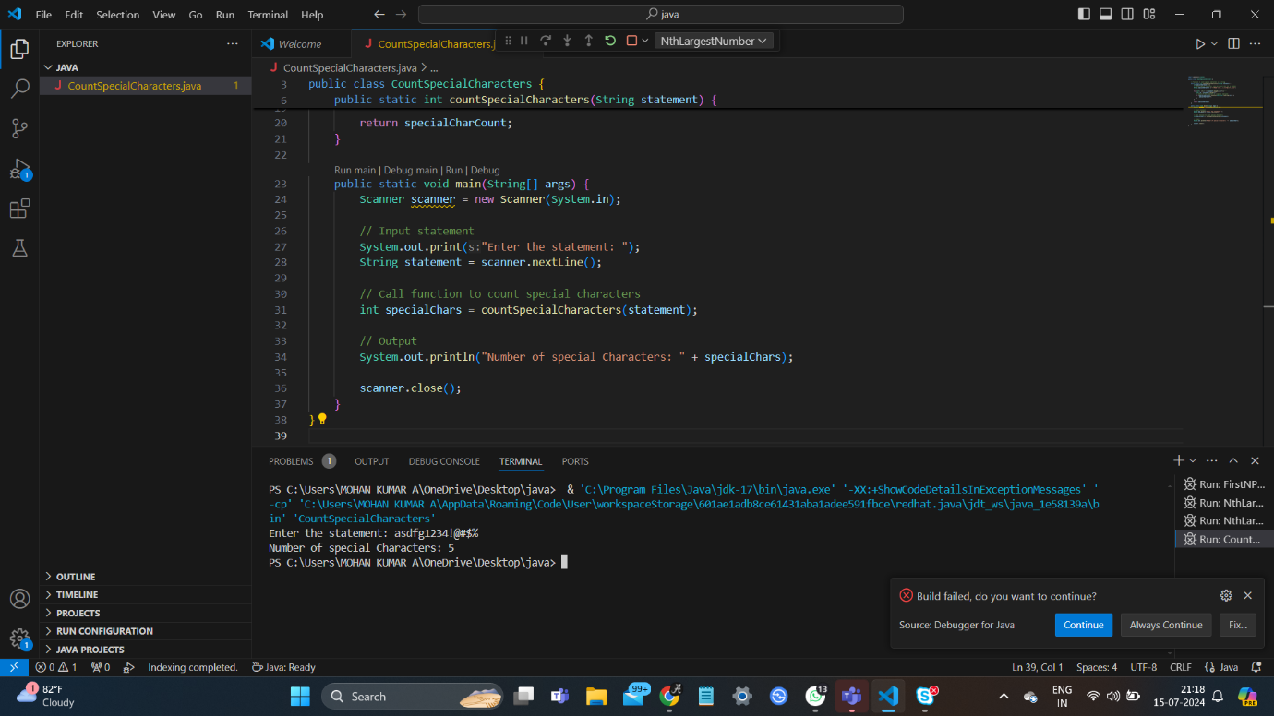

3)Write a Program to Find the Nth Largest Number in a array.

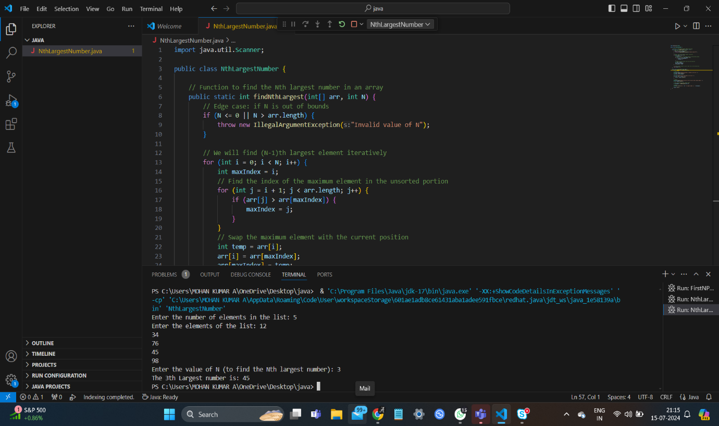

4) Write a program to calculate tax given the following conditions:

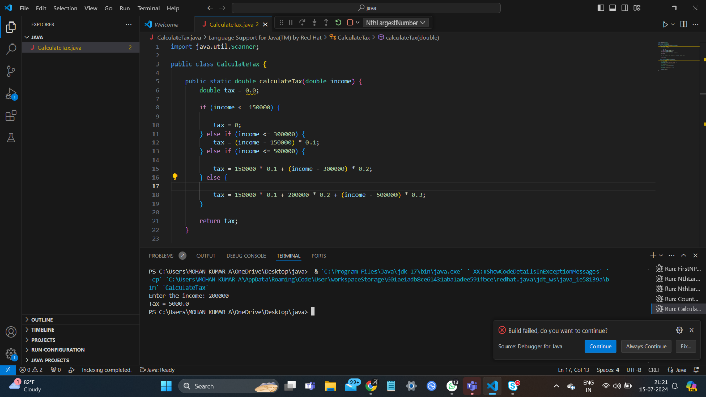

5) Write a program to print the first n perfect numbers. (Hint Perfect number means a positive integer that is equal to the sum of its proper divisors)

